Brand Statement Guide

**Brand Statement Guide**

**“A summary statement can be a powerful branding tool that helps send the message that you’re the right one for the job.”**

**–**[**The Muse**](https://www.themuse.com/advice/the-resume-summary-statement-when-you-need-one-and-how-to-do-it)​

**Key Takeaways:**

1. By the end of this MIlestone, you will be able to develop a draft of your professional brand statement.
2. After reviewing the instructions below, develop a draft of your brand statement, and [submit to a Profile Coach on BCS for feedback](https://www.bootcampspot.com/login).
3. For more insight on developing your brand statement, [click here to view a “Transferable Skills” workshop](https://youtu.be/2CPPcdQKWL4).

Your brand statement expresses your professional value and provides a clear and concise introduction for employers. Think of it as the story you tell the industry about who you are, which includes your education, accomplishments, and skills. This story should be brief and adaptable, allowing it to be tailored according to its use (resume, LinkedIn summary, networking events, etc).

For a guided experience on highlighting your transferable skills and finding ways to tell your story, [click here to view a “Transferable Skills” workshop](https://youtu.be/2CPPcdQKWL4).

**GETTING STARTED**

1. Review the brand statement criteria and samples below to develop a draft for review by a Profile Coach.
2. If this is your first time developing a brand statement, you can use our ['Step-by-Step Guide'](https://careerservices.gitbook.io/career-resources-data-analytics-library/-LjRMfertuZzhAIzJI8A/professional-brand-statements/step-by-step-guide-to-creating-a-brand-statement) for more support.
3. If you’d like additional resources on brand statements, see the resources we’ve included at the end of this guide.
4. Once you’re done, [submit your draft on the Career Services page in BCS](https://www.bootcampspot.com/login). A Profile Coach will offer unlimited feedback to help you develop an Employer Competitive brand statement.

**BRAND STATEMENT CRITERIA**

Your brand statement helps you develop your professional story as it relates to the role you are pursuing. You can modify and adapt your brand statement to other professional materials (resume, LinkedIn, portfolio, cover letter, pitch).

Use the following criteria to develop your brand statement. Your Profile Coach will use the same set of criteria when providing feedback.

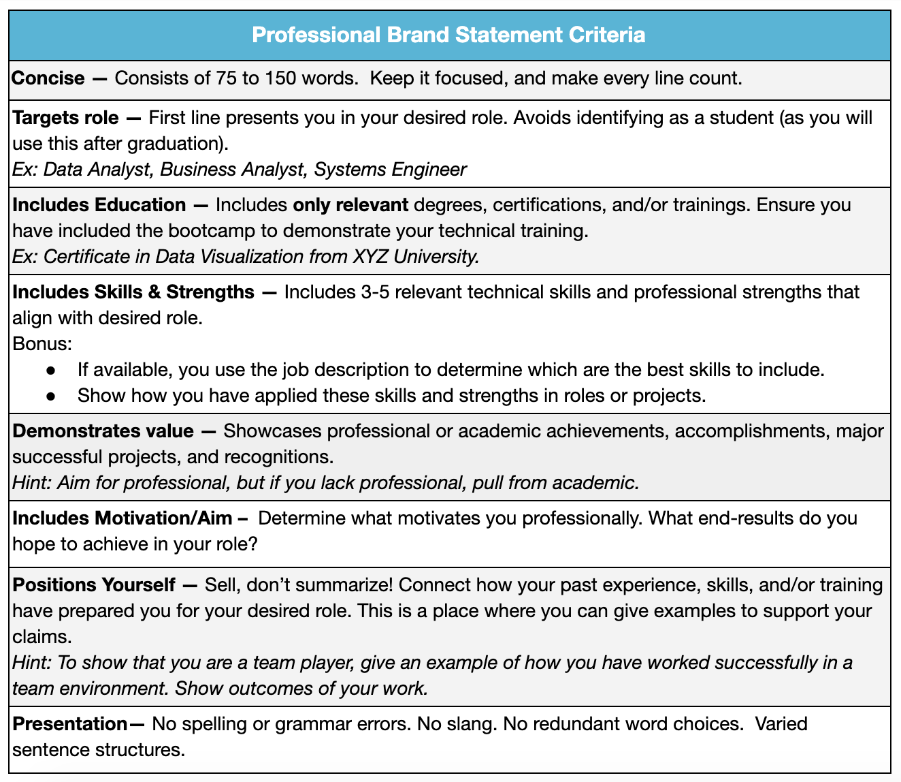

**SAMPLE BRAND STATEMENTS**

**Sample 1 – Entry Level**

Business analyst with a background in mathematics and skills in Excel, VBA, Python, and SQL from Georgia Tech’s Data Analytics and Visualization Bootcamp. Insatiable intellectual curiosity and ability to mine hidden gems located within large sets of structured, semi-structured, and raw data. Enjoys leveraging background and skill set to support detailed and efficient analysis. Recently completed a project in a team of three using data sets from data.gov, Python, JavaScript, and Flask to visualize changes in population in the Greater Atlanta area from 2012 to 2018. My analytical problem solving abilities combined with strengths in collaborating across diverse groups, makes me a valuable addition to any team.

**Sample 2 – Mid Level**

Data architect/modeler with a certificate in Data Visualization from the University of Denver and 5+ years of experience in sales and service industries. Proven technical and leadership aptitude in data warehousing and management environments. Qualifications encompass partnering with business, leadership, and teams to define needs, evaluate risks and issues, and implement architecture, tools, and best practices to enhance decision-making and drive competitive growth. Well versed in presenting to executive staff and driving cross-functional collaboration across varied organizational subcultures, and global teams. Skilled in Python, Pandas, SQL, and data visualization tools such as JavaScript and D3.js. Finds great satisfaction in extracting insights from data that inform decision-making and drive growth.

**Sample 3 – Senior Level**

Accomplished Data Scientist with a B.S. and M.S. in Computer Science and Engineering and a Certificate in Data Science from UCLA. History of success with developing machine learning predictive models, implementing efficient and high-performance applications, and collaborating with different levels of staff to exceed company expectations. Experienced in Python, Java, C++, Hadoop, and both SQL and NoSQL databases (PostgreSQL, MongoDB, MySQL). Excels at leading teams to success and in designing and executing technical solutions. Made extensive positive impact within government, for-profit, and nonprofit organizations. Thrives in environments where strengths in modern analysis tools are utilized.

**ADDITIONAL RESOURCES**

* ​[**3 Elevator Speech Examples for the Job Hunt**](https://www.roberthalf.com/blog/job-market/3-elevator-speech-examples-for-the-job-hunt)​
* ​[**Employers Give Elevator Pitch Advice**](https://www.youtube.com/watch?v=MFDaI30_hgs)